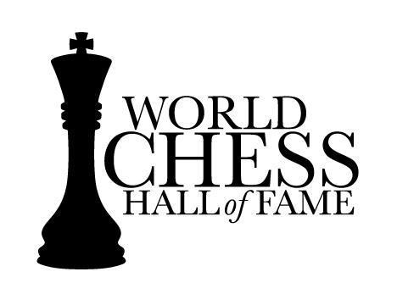

Media Contacts:
Cabanne Howard cabanne@kaleidoscopemg.com (314) 518-7225

Mary McHugh
marymchugh1@mac.com
(314) 910-1528

FOR IMMEDIATE RELEASE

Pivotal Moments in Women’s Chess Highlighted in New Exhibit,
Her Turn: Revolutionary Women of Chess, at the World Chess Hall of Fame

Exhibit is scheduled Thursday, Feb. 4 through Sept. 4, 2016

SAINT LOUIS (Feb. 1, 2016) — Women have played a pivotal role in the development and advancement of the game of chess. Their contributions will be underscored in Her Turn: Revolutionary Women of Chess, an exhibit that opens on Thursday, Feb. 4, at the World Chess Hall of Fame (WCHOF) in Saint Louis.

The exhibit highlights many of the most significant female chess players from the late 19th through early 21st centuries. The exhibit, which is scheduled through Sept. 4, 2016, includes artifacts from the WCHOF’s collection as well as loans from the John G. White Chess Collection at the Cleveland Public Library and numerous private collections. The photographs and other artifacts included in the show tell stories about women chess stars, both in the United States and worldwide.

“These historically significant objects shed light on the illustrious chess careers of these prominent women,” Emily Allred, the exhibition’s curator, said. “Our organization’s mission, in addition to highlighting the cultural and artistic significance of chess, is to increase the awareness around its historical value. Through education, we encourage more young girls and women to take up the game.”

Significant items related to decisive moments in women’s chess history, some on view for the first time to the general public, include: Susan Polgar’s 1996 Women’s World Chess Championship trophy, Alexandra Kosteniuk’s 2008 Women’s World Chess Championship medal, and a bronze medal from the inaugural Women’s Chess Olympiad belonging to Gisela Gresser.

A few of the famous female chess players highlighted will include:
- Vera Menchick, the first Women’s World Chess Champion (London, 1927), who defended her title six times in tournaments throughout the next 17 years and was the first female inducted into the World Chess Hall of Fame in 2011.
- Nona Gaprindashvili and Maya Chiburdanidze, who went on to dominate the women’s title for nearly 30 years (1963-1991) and competed actively against male players.
- Xie Jun and Zhu Chen, who encompassed the Chinese dynasty years (1990s-early 2000s) and competed alongside the infinitely talented Polgar sisters, Susan, Sofia and Judit.

--More--

Her Turn: Revolutionary Women of Chess
Page 2 of 2

In October 2015, the WCHOF opened Ladies’ Knight: A Female Perspective on Chess, an exhibit featuring a group of contemporary female artists including Rachel Whiteread, Yoko Ono and Barbara Kruger, that explores societal issues through art using chess as an artistic medium.
Soon after the opening of Ladies’ Knight, the Chess Club and Scholastic Center of Saint Louis (CCSCSL) began beginner chess classes for women from 6:30 to 7:30 p.m. on Thursday evenings taught by International Master Irene Sukander and Woman Grandmaster Katerina Nemcova.
As part of Her Turn, the CCSCSL will also host an installation of photographs, score sheets and other artifacts related to the 2009-2015 U.S. Women’s Chess Championships, curated by research assistant Catherine Niehaus.
Her Turn: Revolutionary Women of Chess
- Opens Thursday, Feb. 4 and runs through Sept. 4, 2016.
- Admission to Her Turn and Ladies’ Knight: A Female Perspective on Chess is free* with a suggested donation of $5 per person.
*Admission to Kings, Queens & Castles is $5 and free on Tuesdays.

About the World Chess Hall of Fame
The World Chess Hall of Fame is a nonprofit organization committed to building awareness for the cultural and artistic significance of chess. It opened on September 9, 2011, in the Central West End after moving from previous locations in New York and Miami. The World Chess Hall of Fame is located at 4652 Maryland Avenue, housed in an historic 15,900 square-foot residence-turned -business, and features the U.S. and World Chess Halls of Fame, displays of artifacts from the permanent collection and exhibitions highlighting the great players, historic games and rich cultural history of chess. The World Chess Hall of Fame partners with the Chess Club and Scholastic Center of Saint Louis to provide innovative programming and outreach to local, national and international audiences.

For more information, please visit the World Chess Hall of Fame online at www.worldchesshof.org.

###

